CinoSphere – Registration Form Test Cases
Module: Create Account

TC01 – First Name Field Validation
Objective | To verify that the First Name field correctly rejects blank and numeric inputs while accepting a valid alphabetic name.
Action | Navigated to the CinoSphere Create Account page. Tested the First Name field with three inputs:  1. Left it completely blank (null)  2. Entered a numeric string: 12345  3. Entered a valid name: Aditya  All other fields were filled in correctly before clicking GET STARTED each time.
Expected Result | The field should reject blank and numeric inputs with appropriate validation messages. When 'Aditya' is entered, the form should accept it and navigate to the Login page.
Actual Result | The system rejected the blank and numeric inputs with validation messages. When 'Aditya' was entered, the form accepted it and successfully redirected to the Login page.
Result | Successful
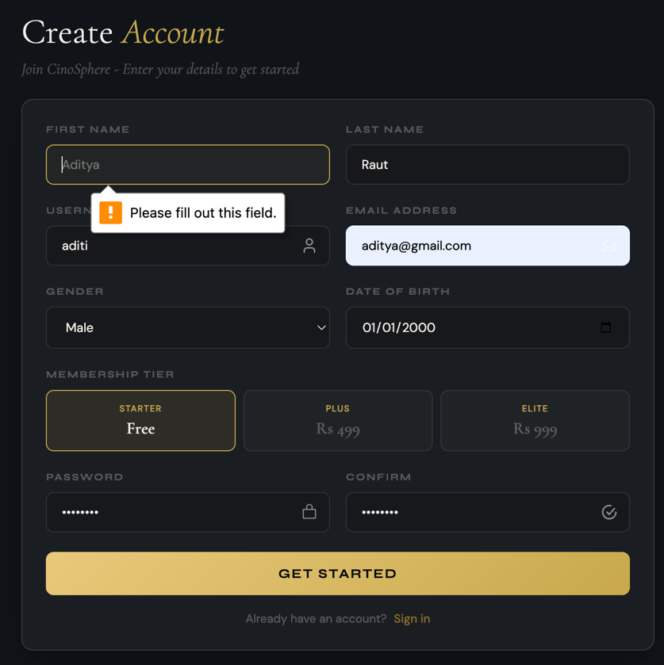

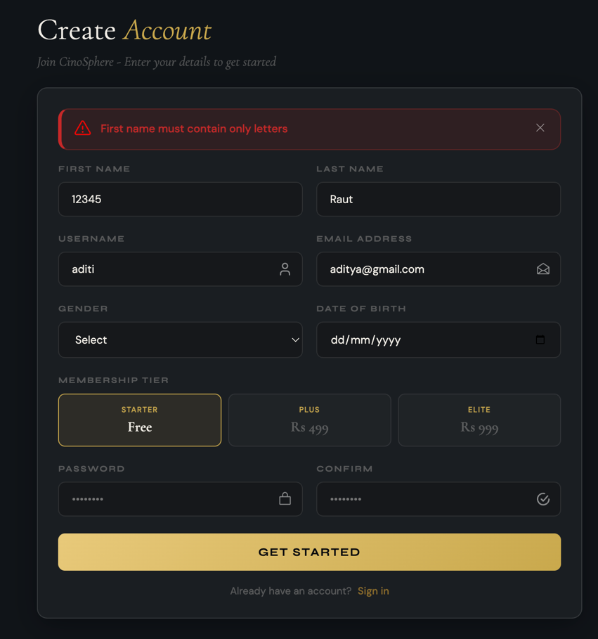

TC02 – Last Name Field Validation
Objective | To ensure that the Last Name field rejects blank and numeric values,but accepts a valid name.
Action | Navigated to the Create Account page. Used the Last Name field as follows:  1. Null value  2. Numeric Value 12345  3. Valid Name:Prasad  All other fields were correctly filled before clicking Get Started each time.
Expected Result | The field rejects blank and numeric values with validation messages.When Raut is entered in th Last Name field, the form should be accepted.
Actual Result | Blank and numeric values were rejected with validation messages.When Prasad was entered in the Last Name field,the form was accepted
Result | Successful
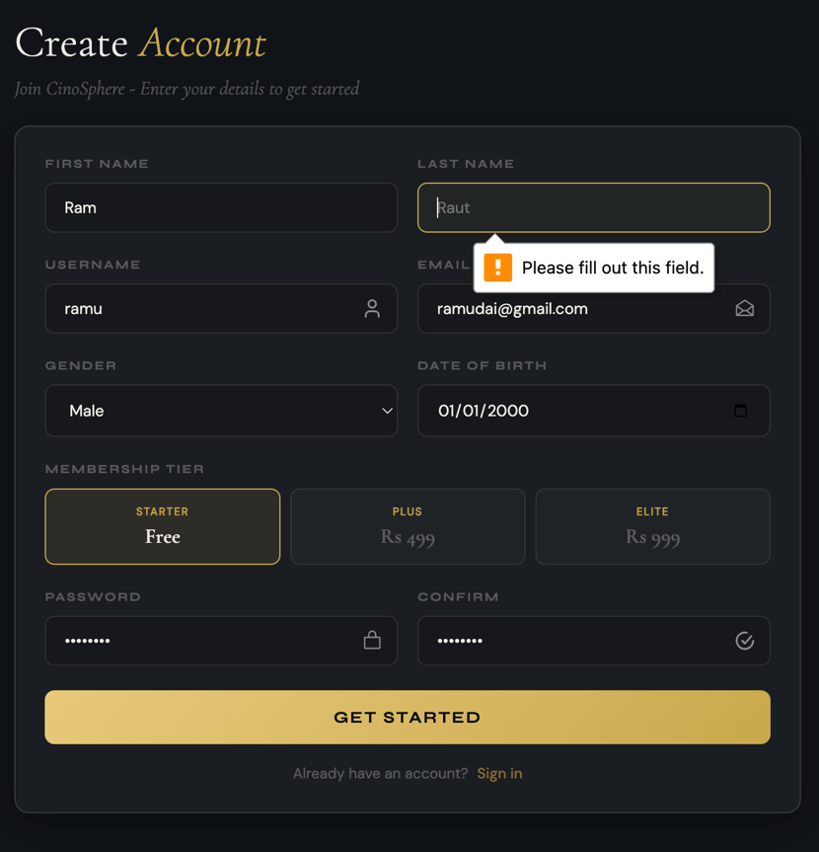

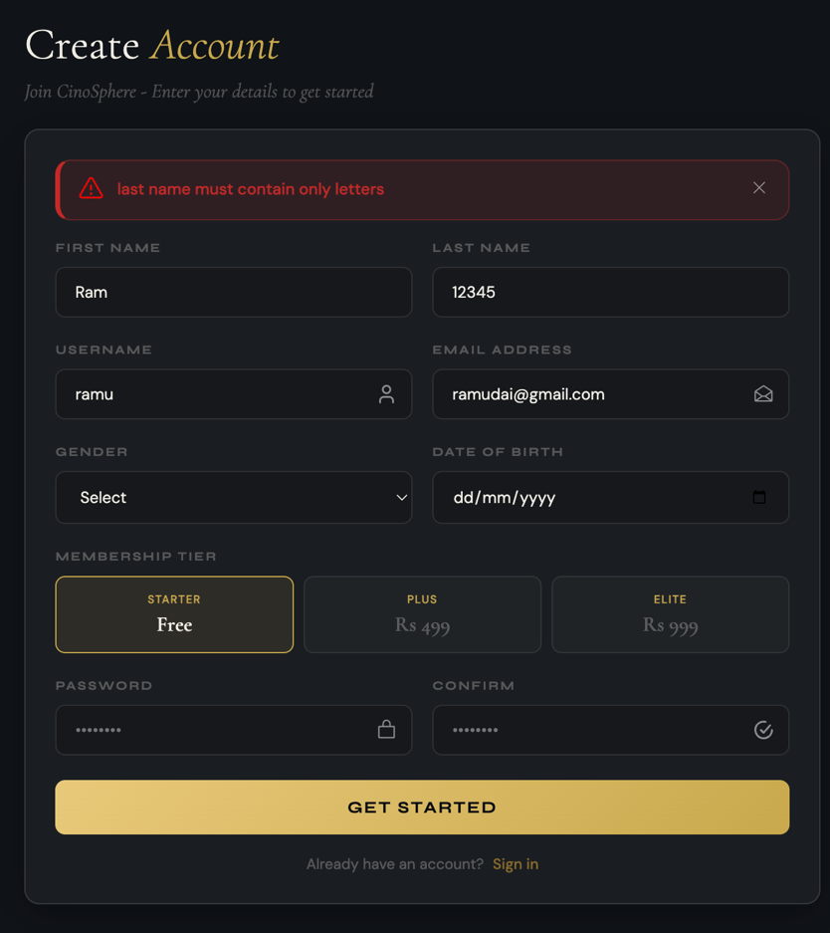

TC03 – Username Field Validation
Objective | To ensure that the Username field does not accept a blank field and accept a valid field.
Action | Navigated to the Create Account page and in the Username field, field tested two inputs:  1. A completely blank(null) input in that field.  2. Enter a valid username:”sabal123” in the field  All other fields were filled in correctly before clicking Get Started each time.
Expected Result | It should not accept a blank value with a validation message.After entering a valid value like”sabal123”, the form should accept it.
Actual Result | It did not accept the blank value with a validation message, and after entering “sabal123” in the field for username, the form accepted it.
Result | Successful
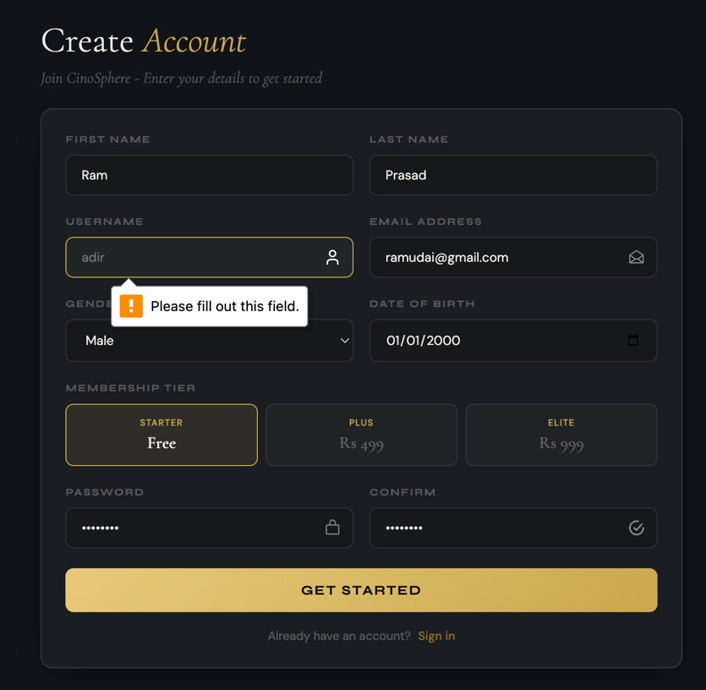

TC04 – Email Address Field Validation
Objective | To ensure that the Email Address field does not accept a blank field or an improper value, and does accept a valid field.
Action | Navigated to the Create Account page and in the Email Address Field, tested three inputs:  1. A completely blank(null) input in that field.  2. An email input without the required”@” symbol:sabal123@gmail.com.  3.A valid email input:sabal123@gmail.com
Expected Result | The field should not accept a blank value or an incorrect value with a validation message.Entering a valid email in the field, the form should accept it.
Actual Result | It rejects blank value or an incorrect value with a validation message, and after entering “sabal123@gmail.com” in the field for email, the form accepted it.
Result | Successful
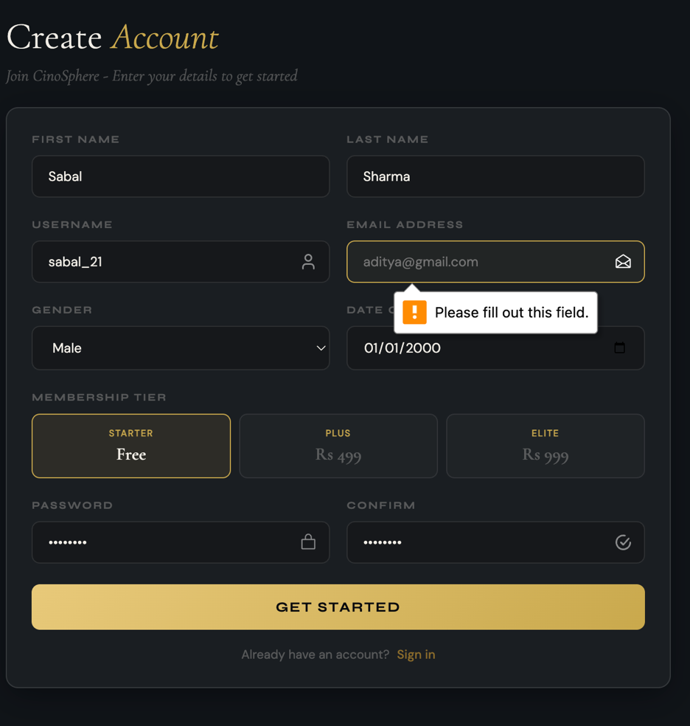

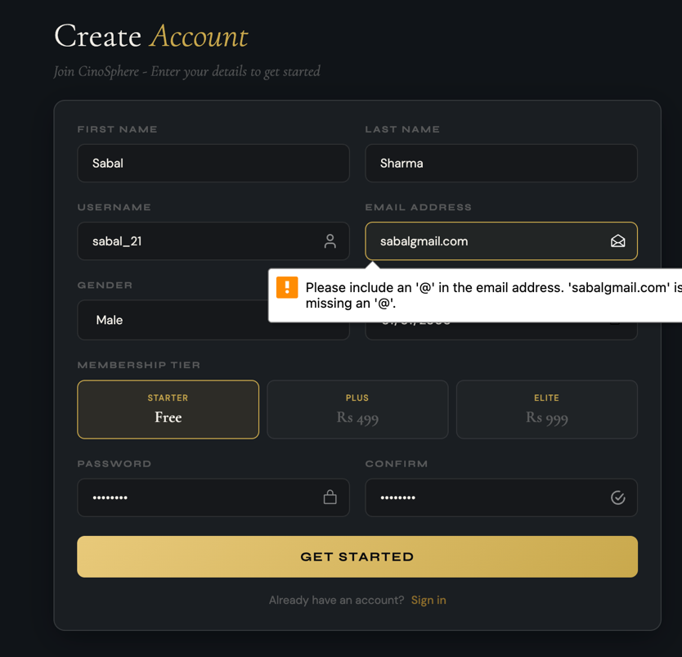

TC05 – Gender Field Validation
Objective | To ensure that the Gender field does not accept a blank value for gender.
Action | Navigated to the Create Account page and in the Gender field, field tested two scenarios:  1. Gender was not selected from the drop down and the default ‘Select’ option was left as is.  2. Gender was selected from the drop down.  All other fields were filled in correctly before clicking GET STARTED each time.
Expected Result | Should not accept the form with no gender selected with a validation message, and should accept the form after a valid gender is selected from the drop down.
Actual Result | It did not accept the form with no gender selected with a validation message, and after selecting a valid gender from the drop down, the form accepted it.
Result | Successful

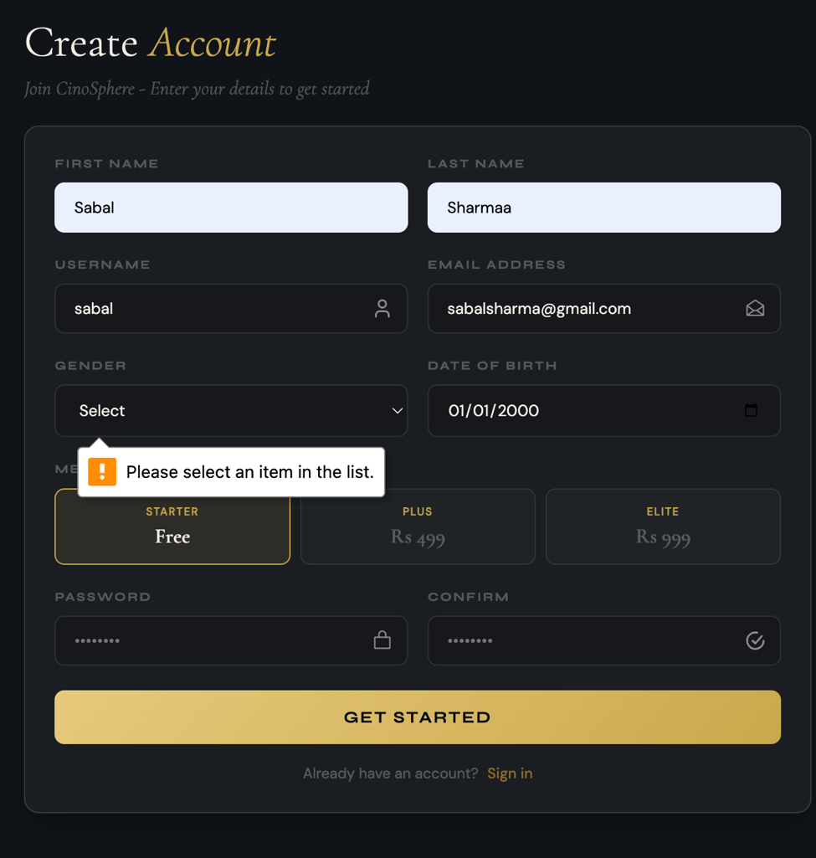

TC06 – Date of Birth Field Validation
Objective | To ensure that the Date of Birth field does not accept a blank field or a date that has not yet occurred, and does accept a valid field.
Action | Navigated to the Create Account page and in the Date of Birth field, field tested three inputs:  1. A completely blank (null) input in that field.  2. A date that was in the future and had not yet occurred.  3. A valid date of birth in the past All other fields were filled in correctly before clicking GET STARTED each time.
Expected Result | Should not accept a blank value or a date that has not yet occurred with a validation message. After entering a valid value like a date of birth that has already occurred in the past, the form should accept it.
Actual Result | It did not accept the blank value or a date that has not yet occurred with a validation message, and after entering a valid value like a date of birth that has already occurred in the past, the form accepted it.
Result | Successful

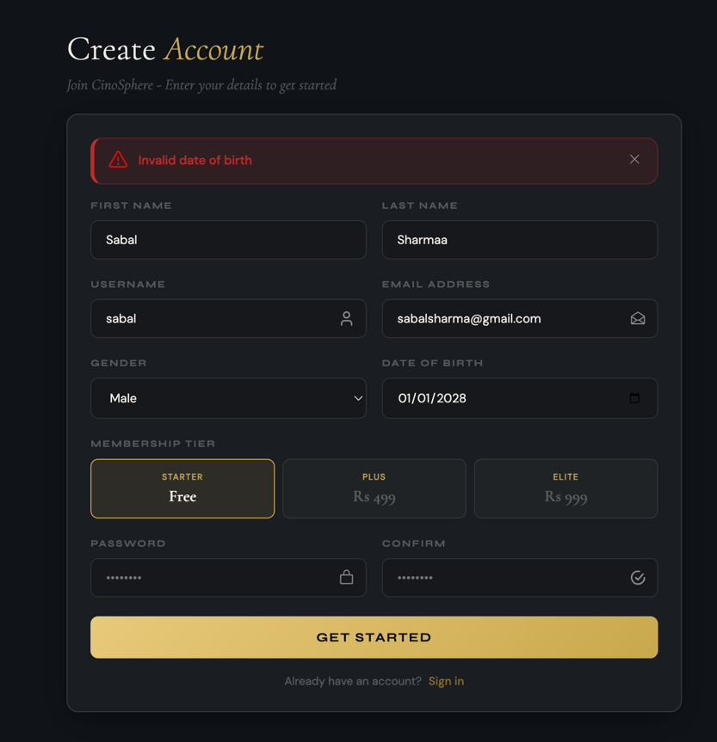
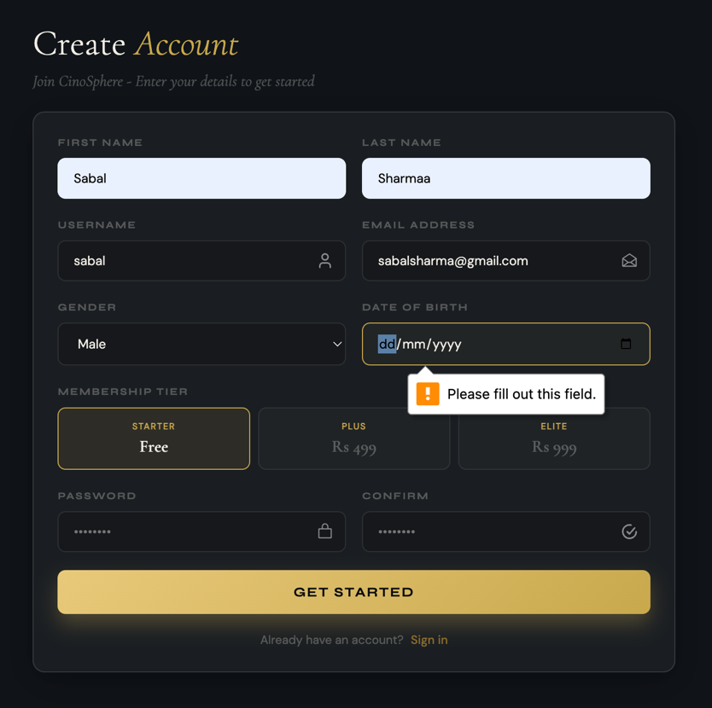

TC07 – Password Field Validation
Objective | To ensure that the Password field rejects a empty input
Action | Navigated to the Create Account page and in the Password field,tested with two inputs:  1. A completely blank (null) input in that field. 2. A valid password was entered.  All other fields were filled in correctly before clicking GET STARTED each time.
Expected Result | It should reject a empty input with validation message. If a valid password is entered, the form should accept it.
Actual Result | It rejected the empty input with a validation message. When a valid password was entered, the form accepted it and proceeded successfully.
Result | Successful
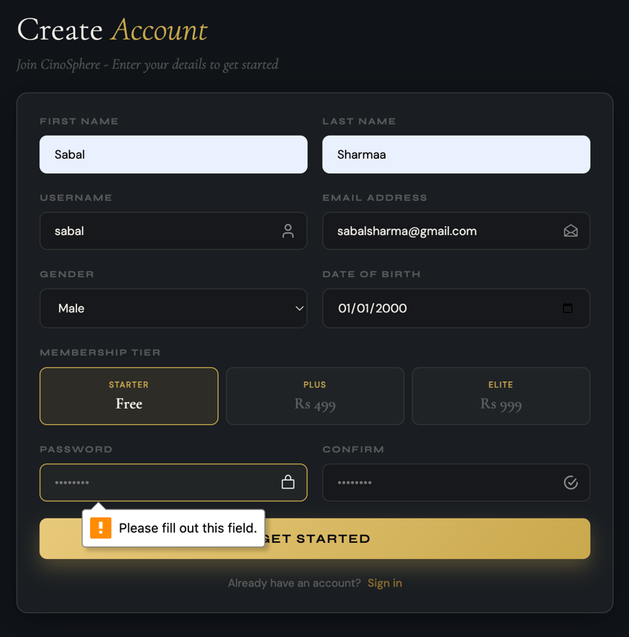

TC08 – Confirm Password Field Validation
Objective | To ensure that the Confirm Password field does not accept a blank field or a password that does not match, and does accept a correct field.
Action | Navigated to the Create Account page and in the Confirm Password field, field tested three inputs:  1. A completely blank (null) input in that field.  2. A password input that does not match the Password field.  3. The correct password that matches the Password field. All other fields were filled in correctly before clicking GET STARTED each time.
Expected Result | Should not accept a blank value or a password that does not match with a validation message. After entering the correct password matching the password field, the form should accept it.
Actual Result | After entering the correct password matching the password field, the form should accept it.
Result | Successful
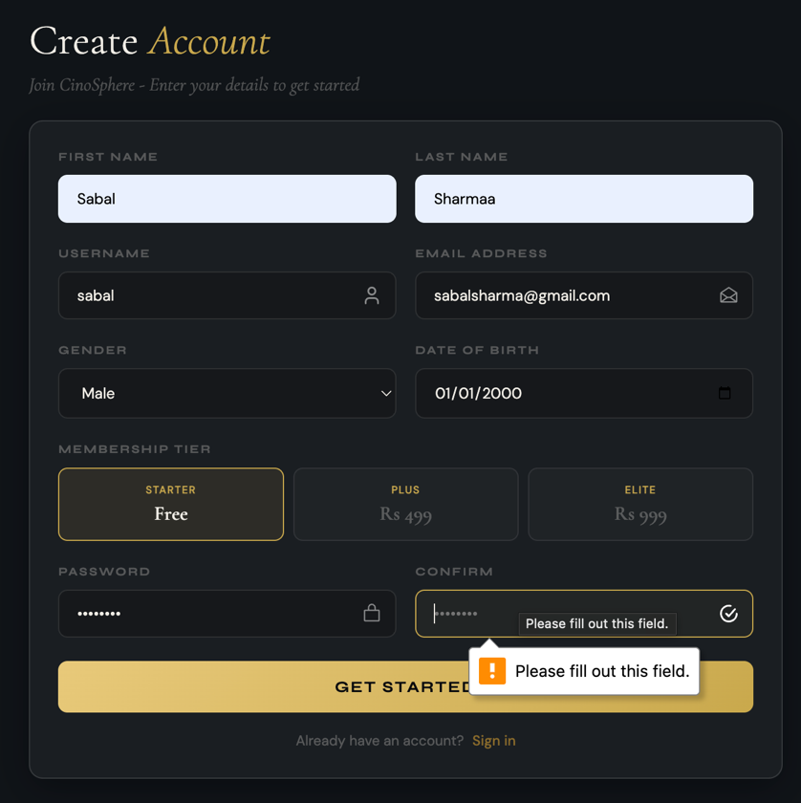

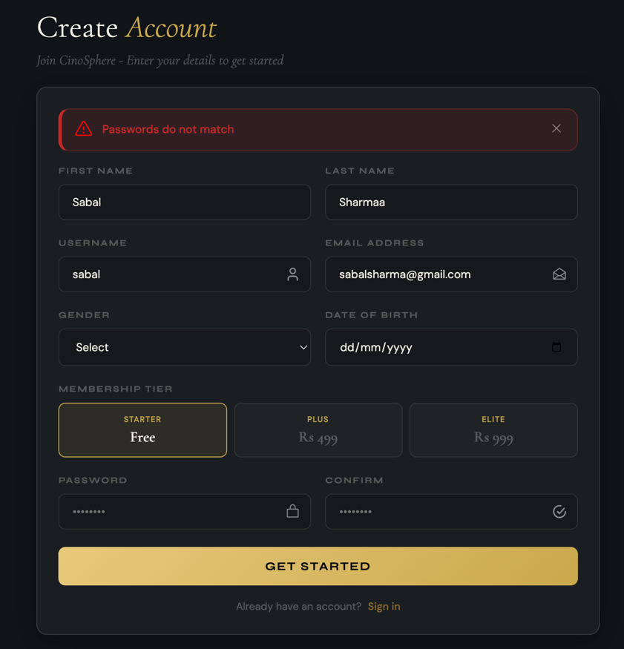

TC09 – Duplicate Username Validation
Objective | To ensure that username cannot be registered twice and must be unique in the system.
Action | Navigated to the Create Account page and filled in all fields correctly, but entered a username that is already registered in the system, and clicked GET STARTED.
Expected Result | System should not register the user and display an error for the user since that username is already registered in the system.
Actual Result | System displayed an error for the user since that username is already registered in the system and did not register that user.
Result | Successful

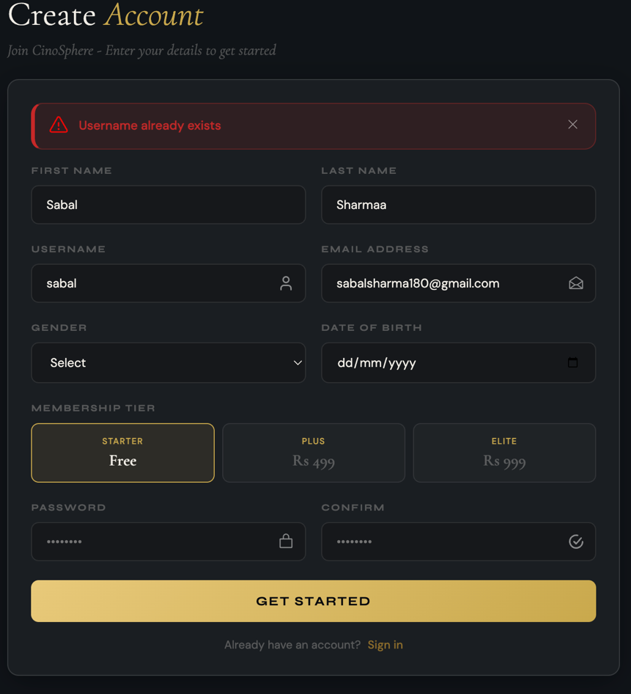

TC10 – Duplicate Email Validation
Objective | To ensure that the system should not register if entered email is associated with an existing account.
Action | Navigated to the Create Account page and filled in all fields with valid input but with an email that already exists.
Expected Result | Should not be able to register and system should throw relevant error message that email already exists.
Actual Result | System detected that existing email is being used and threw an error message to user that email already exists. Was not able to register.
Result | Successful

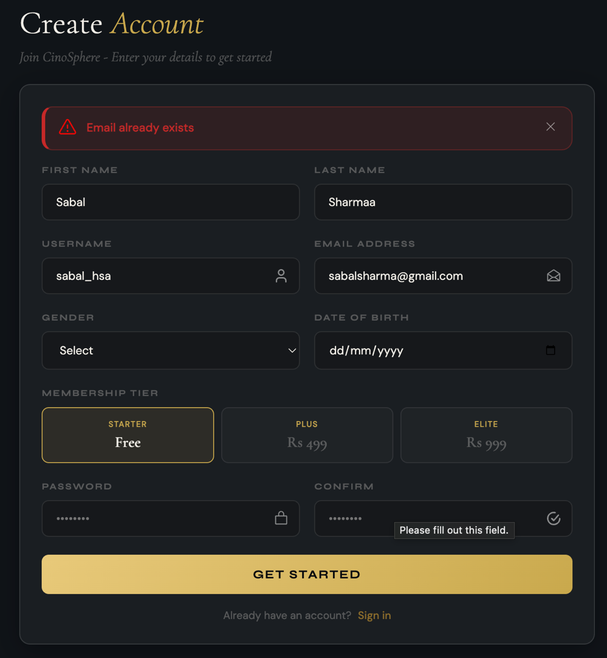

TC11 – Successful Account Registration
Objective | To ensure that a user can successfully register when all information in each field is valid.
Action | Navigated to the Create Account page and filled in all fields with valid input  First Name: Sabal, Last Name: Sharma, Username: sabal12345, Email Address: sabal@gmail.com, Gender: Male, Date of Birth: 12-12-2000, Password:admin123, Confirm Password:admin123.Selected Starter(Free) Membership Tier and clicked Get Started.  .
Expected Result | Should accept all valid values and register the account, leading the user to the Login page.
Actual Result | Accepted all legitimate values and registered the account with no errors, resulting in a Successful Registration redirecting to the Login page.
Result | Successful

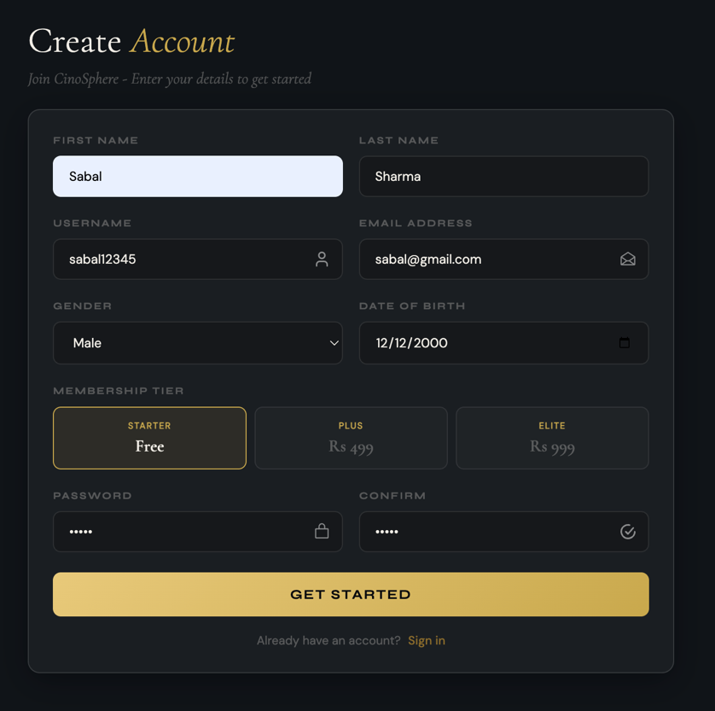

Module: Login

TC12 – Login Username Field Validation
Objective | To check if the user is able to enter with incorrect values in the Username field on Login page.
Action | Navigated to login page and tested the Username with three inputs:  1.kept it blank completely.  2.Entered a username that doesn’t exist.  3.Entered a username that does exist with the correct password.
Expected Result | User Should not be able to enter with blank or incorrect username and get rejected with the appropriate message. If user username that already exists then the user should be able to login.
Actual Result | System returned correct validation messages for blank username or username that doesn't exist. When a username that is registered and password that matches is entered, user was logged in.
Result | Successful

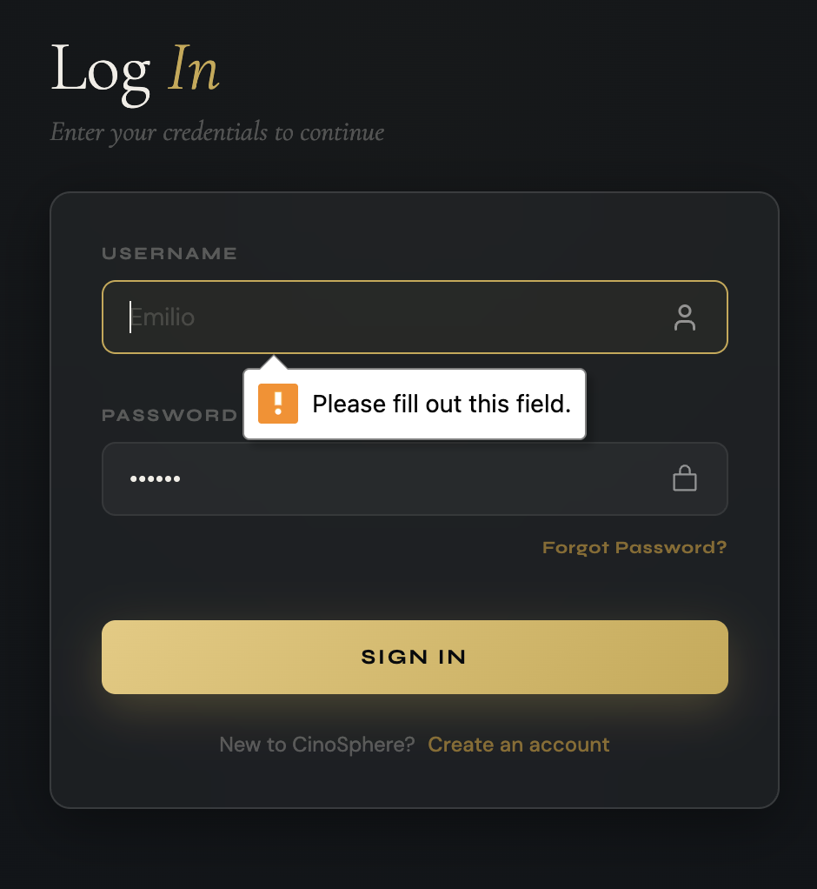

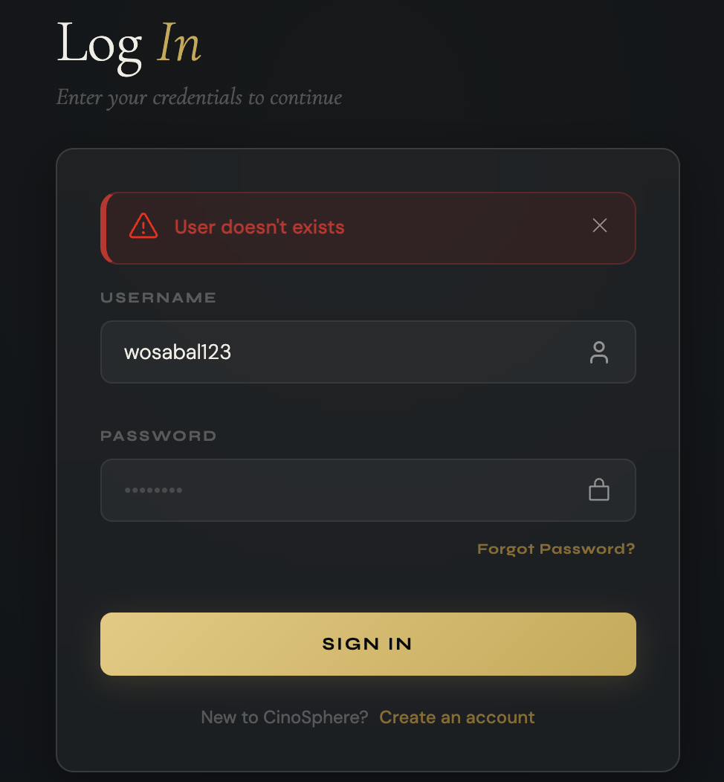

TC13 – Login Password Field Validation
Objective | To check if user is able to enter with incorrect values in the password field on Login page.
Action | Navigated to login page and tested the Username with three inputs:  1.kept it blank completely.  2.Entered a wrong password.  3.Entered a correct matching password
Expected Result | User Should not be able to enter with blank or incorrect passwords and get rejected with the appropriate message. If user inserted the correct matching password then should be able to login.
Actual Result | System returned correct validation messages for blank password or incorrect password. When a username that is registered and password that matches is entered, user was logged in.
Result | Successful

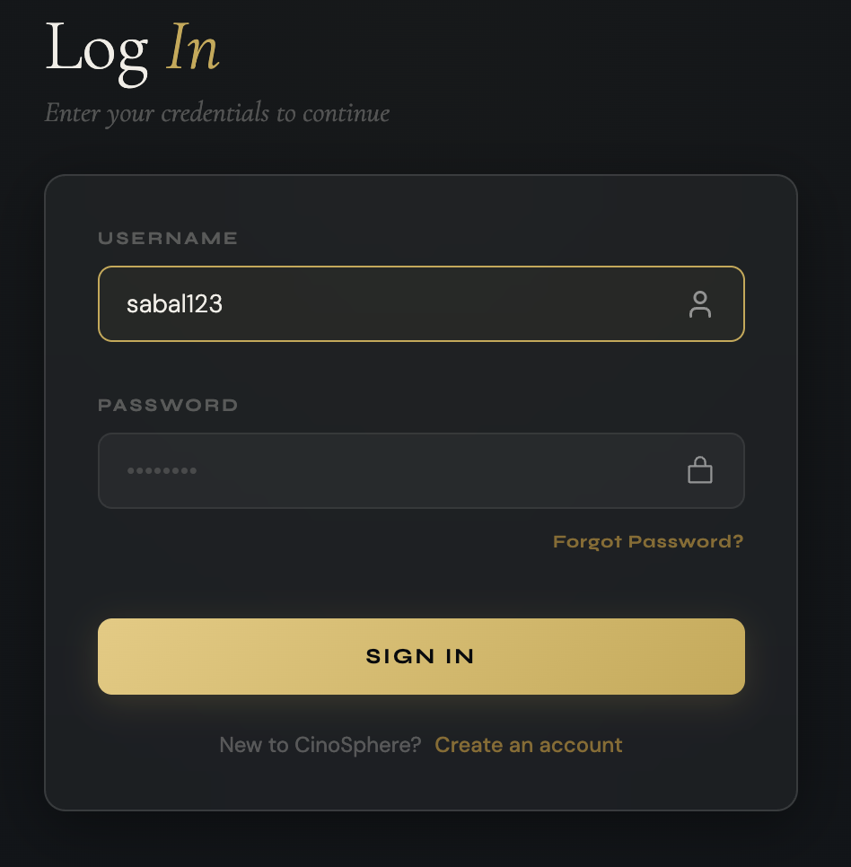

TC14 – Unverified Account Login Attempt
Objective | To check if test is able to log in with a username that exists but the account has not yet been verified/approved by admin.
Action | Went to Login page. Entered the username and password for an account that exists in the system but has not been approved by admin yet. Clicked SIGN IN.
Expected Result | Should not be able to log in and system should return "Wait for Admin to verify".
Actual Result | System detected that account is unverified and returned "Wait for Admin to verify".
Result | Successful

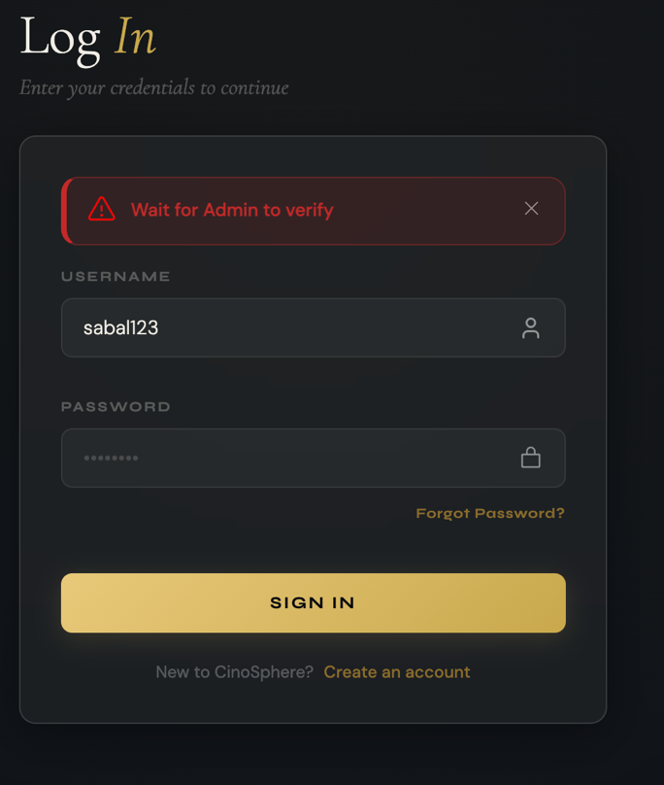

TC15 – Verified Account Login Attempt
Objective | To check if user is able to log in with correct credentials.
Action | Went to Login page. Entered a username that is registered in the system and the correct corresponding password.
Expected Result | System should not return any kind of error message and should be redirected to the home page
Actual Result | User was logged in correctly.
Result | Successful

